Connecting Norbert (via Cable)

Connect the USB adapter so the “Petoi USB Adapter” is right way up and facing forward (the other set of pins are for debugging purposes):

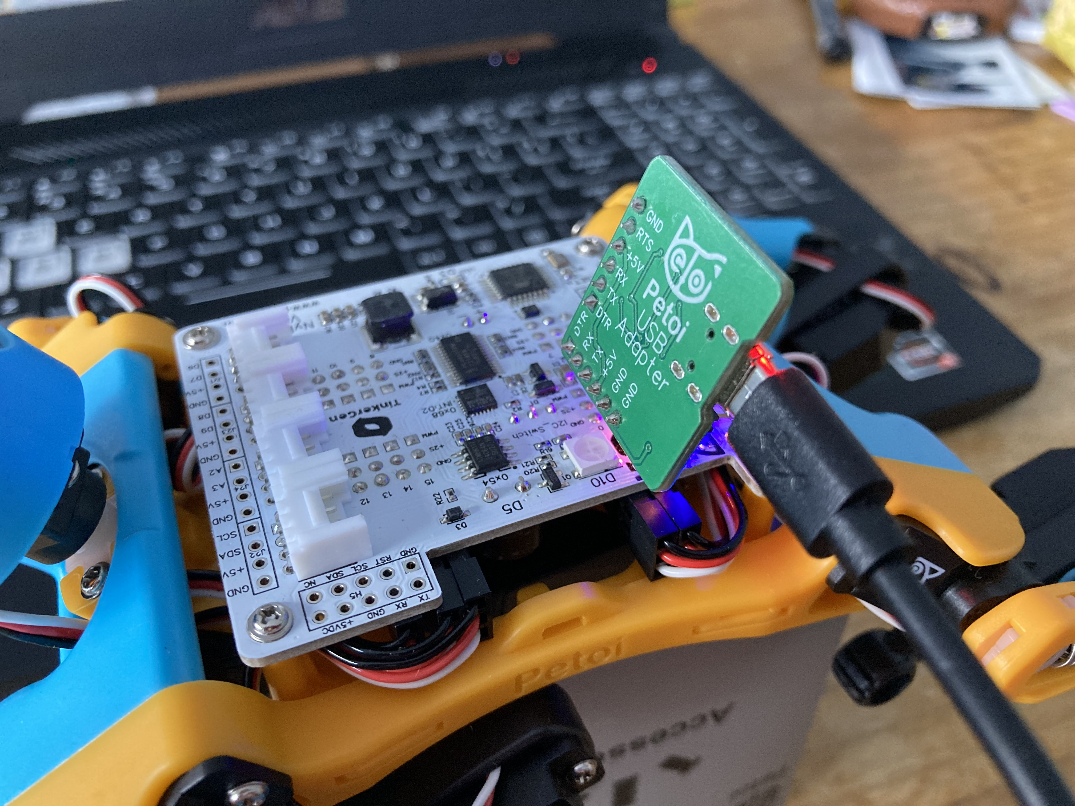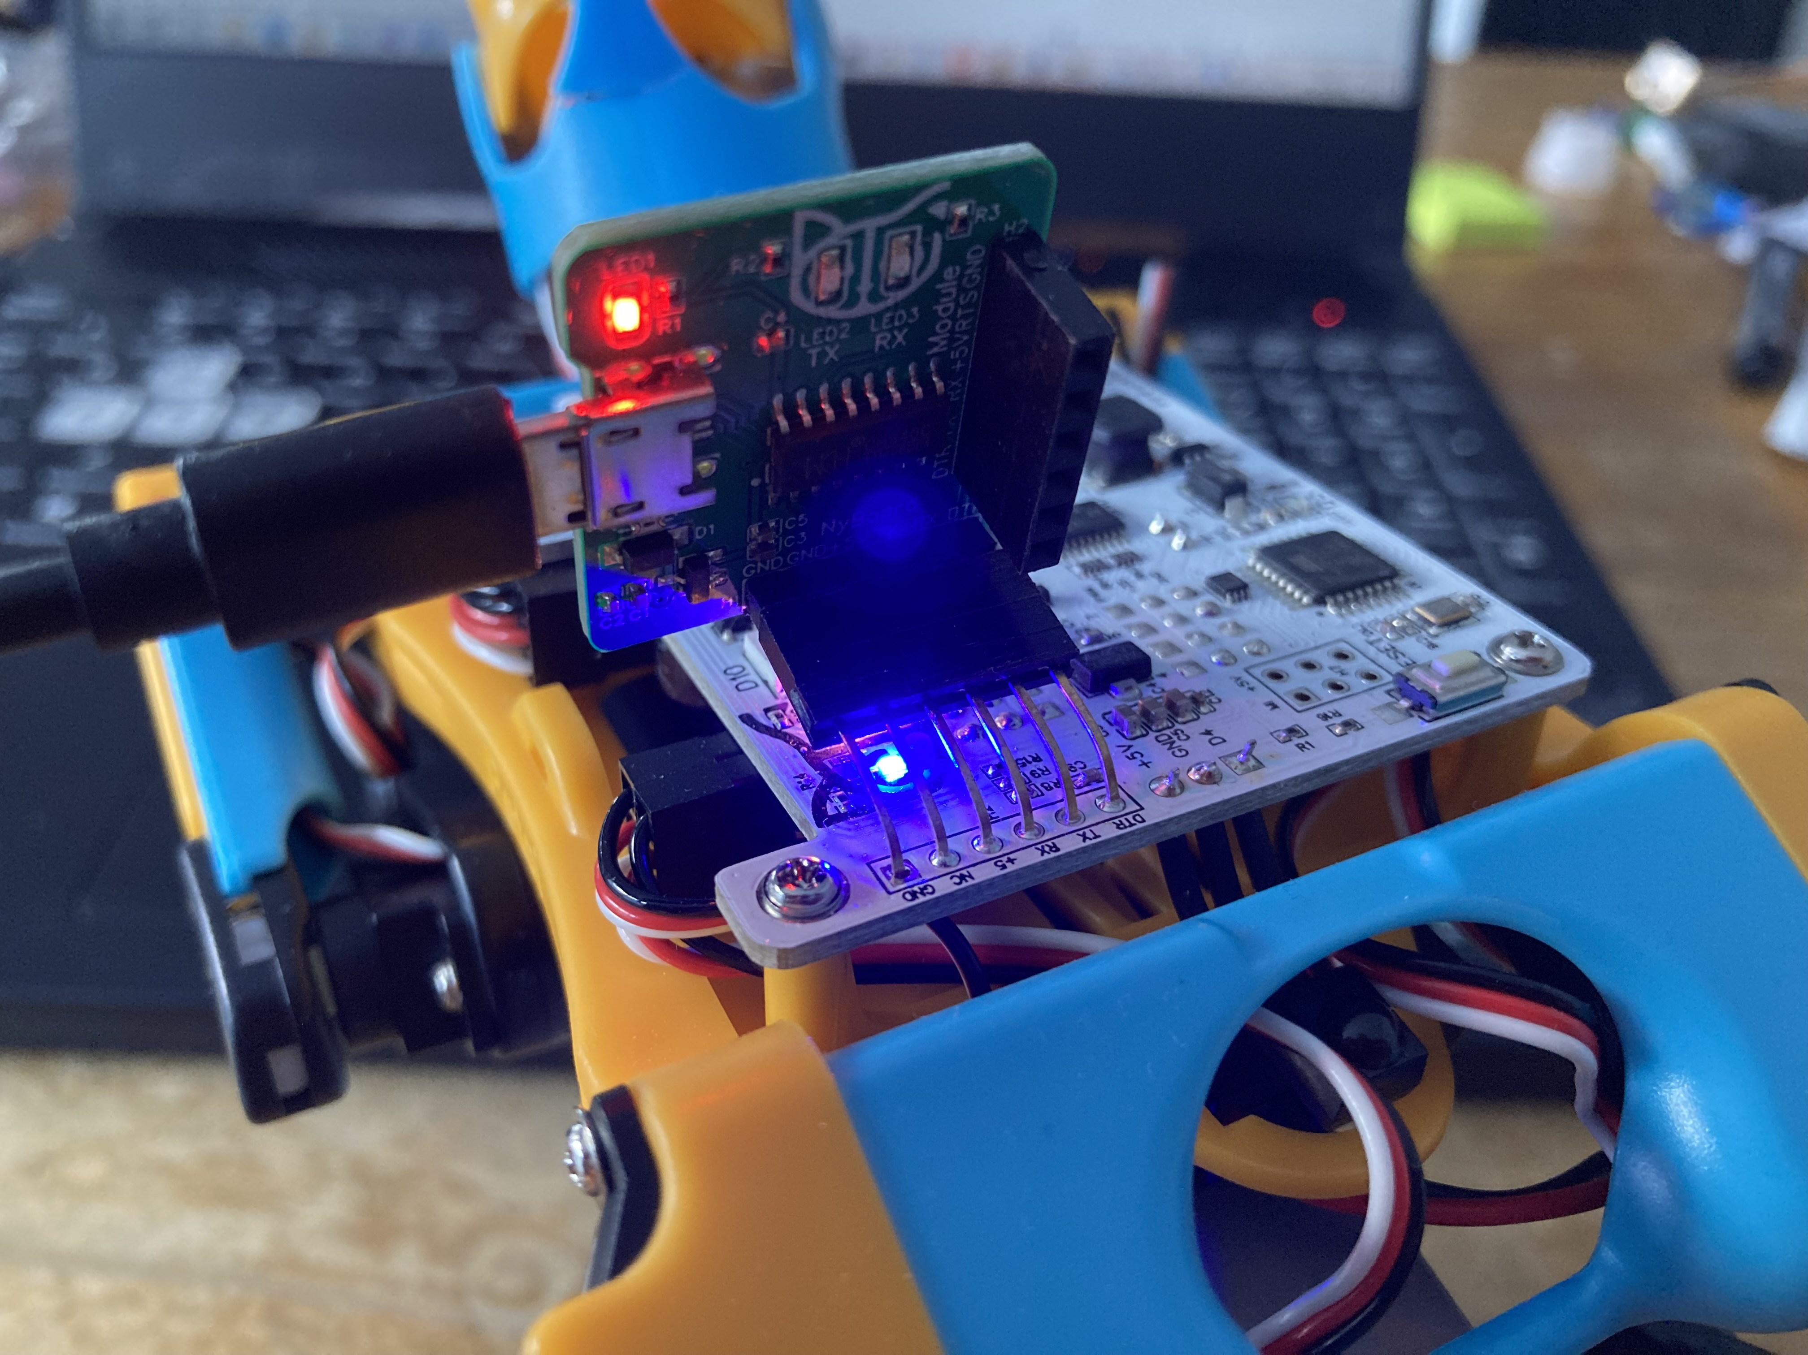

To find the serial port, open Computer Management and then look at “Device Manager”. Look at the serial port which contains “USB-SERIAL CH340”:

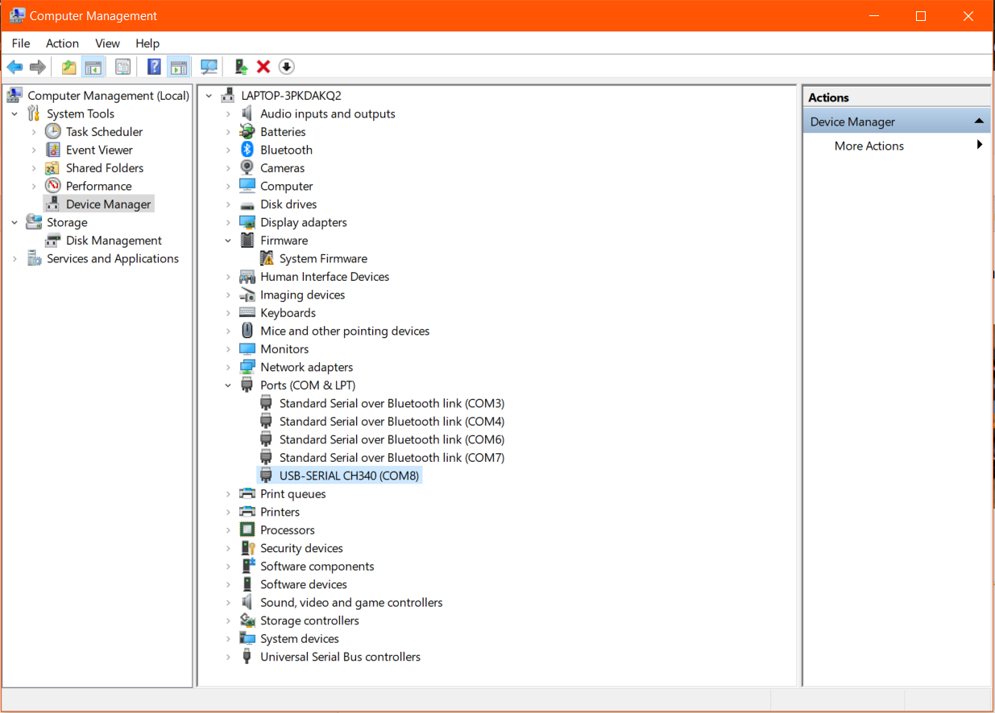

Connecting Norbert (via Bluetooth)

Firstly, the Bluetooth adapter needs to be attached (like the USB adapter shown above).

To connect via Bluetooth, navigate to Bluetooth & devices, click ‘Add device’ and select ‘Petoi-XXXX' (only try the BLE version if a non-BLE version doesn’t appear – most of the time it doesn’t work). If nothing appears, make sure the ‘Bluetooth devices discovery’ is set to ‘Advanced’ (circled below).

You’ll be prompted to enter a password, enter ‘0000’.

Now you need to find out which COM port is the outgoing one so scroll down and look at ‘More Bluetooth settings’.

Navigate to ‘COM ports’ page and look at the outgoing port:

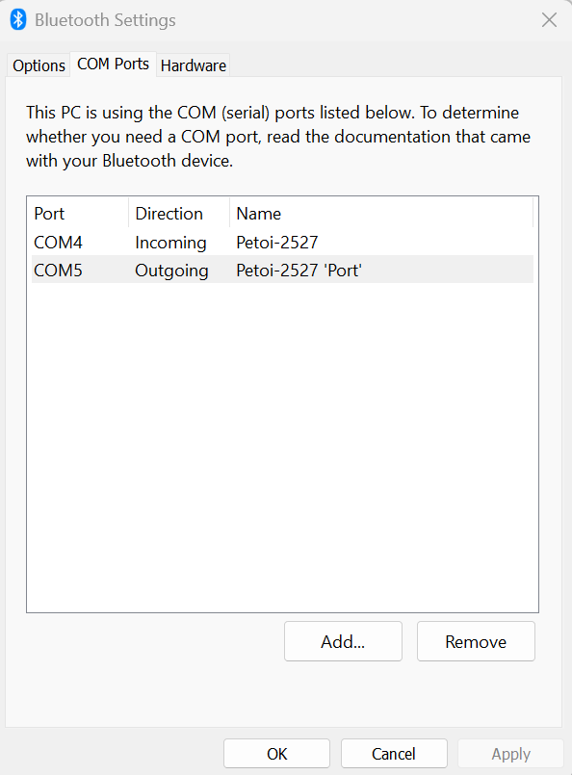

In this case, COM5 is the port we use to specify communication with Norbert.

Configuring Norbert

Each time the mode is to be changed or a Bluetooth connection is re-established, you’ll likely need to use the Firmware Uploader. Run UI.exe to use the Petoi Desktop App:

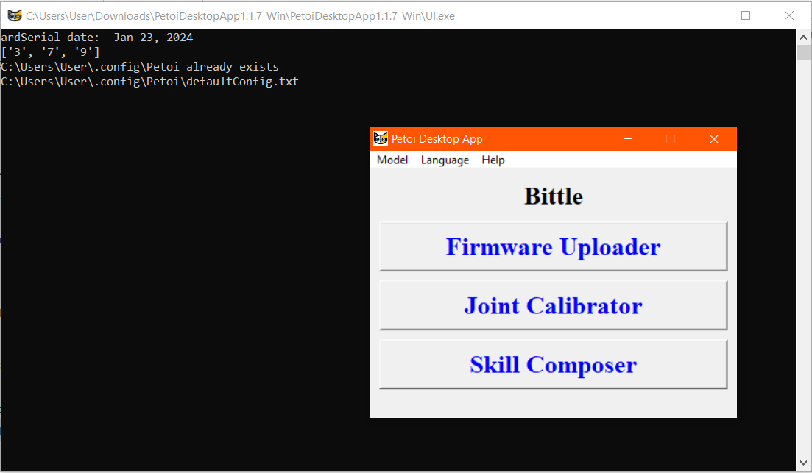

Select ‘Firmware Uploader’. You’ll notice text appears in the terminal, don’t worry about it (or the errors that may appear), just wait for the GUI to display:

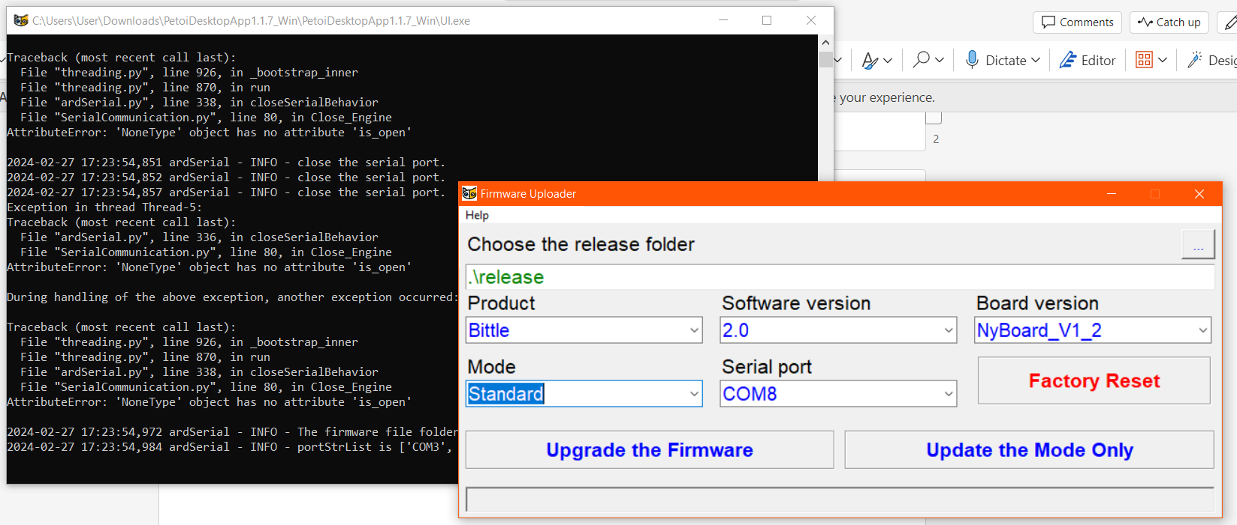

Ensure that the ‘Product’ field is set to ‘Bittle’, ‘Software Version’ is set to 2.0 (this is the latest version at time of writing) and ‘Board Version’ is set to ‘NyBoard_V1_2’ (as this is the circuit board that comes with Bittle, if using Bittle X it would be a BiBoard_VX_X – if in doubt the name can be seen on the circuit board).

**Mode**

'Standard’ mode is Bittle’s default mode. In this mode, the gyroscope sensor is enabled so the robot will automatically balance. *In this mode, you cannot read/write to the digital/analog pins, attempting to will cause the robot to beep and errors to appear.*

If the mode is set to ‘Mind+’, the gyroscope sensor is disabled so the robot will not automatically balance. There are other modes which may be required for certain attachments (Petoi’s Extensible Modules). This mode must be used if wanting to read/write to the digital/analog pins.

**Serial Port**

Select the Serial Port which corresponds to the one being used for the Bluetooth connection (as described above).

**‘Upgrade the Firmware’ button**

This is used if a new version of the Desktop App is downloaded or if Bittle is being used for the first time. Otherwise it can be used to change the software version and reset the ‘Parameters’ (joint and IMU/gyro calibration), after which the ‘Main Function’ will run.

**‘Update the Mode Only’ button**

This runs the ‘Main Function’ so it can be used to change Serial Port and Mode but will not prompt you to reset any Parameters.

Using Mind+ to Program Norbert

The extension library is located at: <https://github.com/PetoiCamp/Petoi_MindPlusLib>

If opening the application by clicking on its icon, the Petoi Coding Blocks extension will have to be added manually every time. A way around this is to open a particular file that uses the extension (such as .mp or .sb3) as Mind+ will open with the extension enabled by default.

IR distance & Light sensor connects to analog pins, PIR &Touch sensor connects to digital pins